Assignment 9.1

Question 1. If Z is norm (mean = 0, sd = 1)

Find P(Z > 2.64)

Solution:-

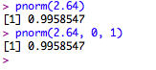

Find P(|Z| > 1.39)

Solution: -

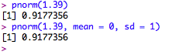

Question 2. Suppose p = the proportion of students who are admitted to the graduate school of the University of California at Berkeley, and suppose that a public relation officer boasts that UCB has historically had a 40% acceptance rate for its graduate school. Consider the data stored in the table UCBAdmissions from 1973. Assuming these observations constituted a simple random sample, are they consistent with the officerâ..s claim, or do they provide evidence that the acceptance rate was significantly less than 40%?

Use an Î± = 0.01 significance level.

Solution: -

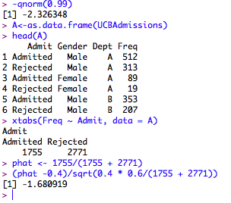

Our test statistic is not less than −2.32, so it does not fall into the critical region. Therefore, we fail to reject the null hypothesis that the true proportion of students admitted to graduate school is less than 40% and say that the observed data are consistent with the officer’s claim at the α = 0.01 significance level.